Titiro means look

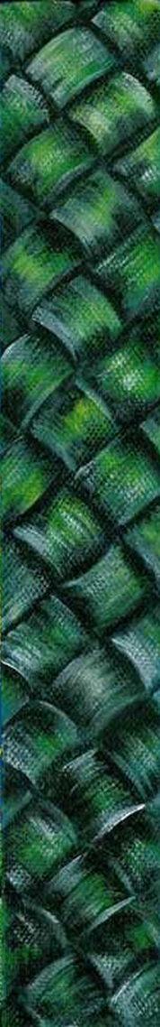

Titiro = Look
Titiro ki te Tūī
Look at the Tūī
Titiro mai = Look in my direction
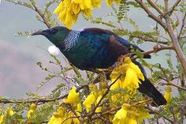
Titiro ki te ... = Look at the...
Titiro ki te rākau
Look at the tree
Titiro ki te manu .
Look at the bird .
Titiro ki te kōwhai
Look at the kōwhai

You can add an adjective on to describe what you are looking at:
Titiro ki te manu _________ = Look at the _________ bird
Titiro ki te manu ātaahua = Look at the beautiful bird
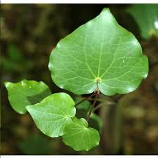

Titiro ki te rau = Look at the leaf
Titiro ki te rau manawa = Look at the heart-shaped leaf
Titiro ki te rau kawakawa = Look at the kawakawa leaf

You can replace the ‘te’ (which means ‘the’ / singular) in each sentence above with ‘ngā’ (which means ‘the’ / plural) if you want to talk about more than one thing.
Titiro ki ngā rau = Look at the leaves
Titiro ki ngā rākau = Look at the trees
Titiro ki ngā putiputi kōwhai = Look at the yellow (kōwhai) flowers
Whakarongo means listen

Whakarongo = Listen
Whakarongo mai = Listen to me
Whakarongo ki te ... = Listen to the...
Whakarongo ki te manu . Listen to the bird .
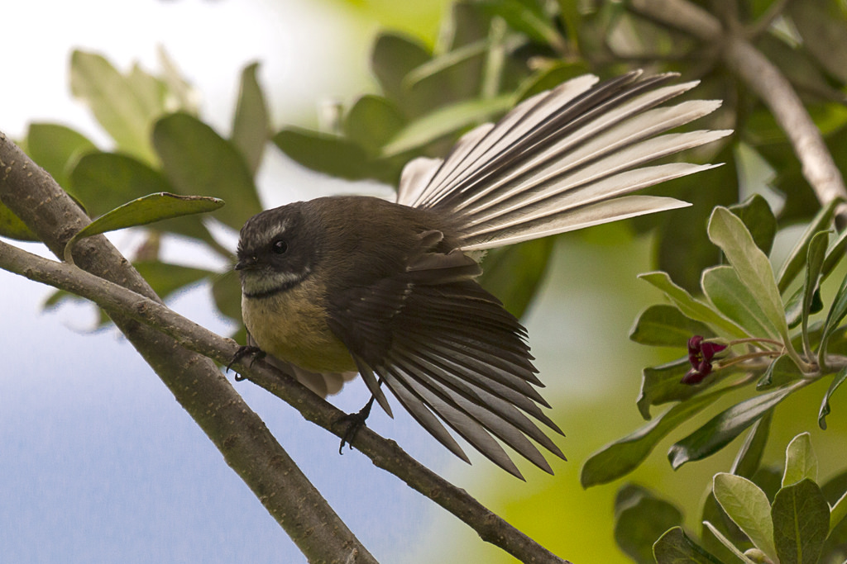
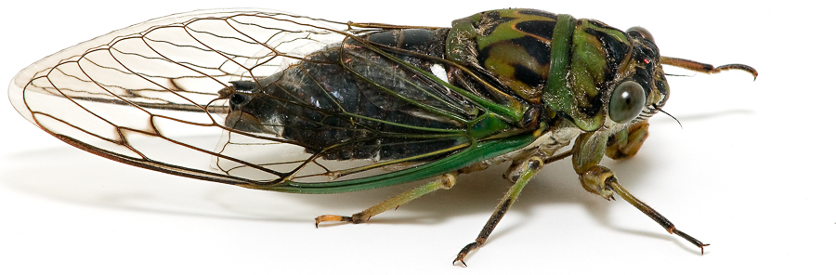

Whakarongo ki te pīwaiwaka
Listen to the fantail
Whakarongo ki te kihikihi
Listen to the cicada
Whakarongo ki te Tūī
Listen to the Tūī

You can add an adjective on to describe what you are listening to:
Whakarongo ki te manu _________ = Listen to the _________ bird
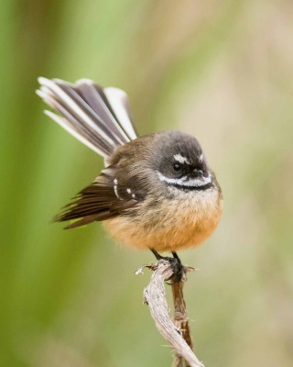
Whakarongo ki te manu ātaahua = Listen to the beautiful bird

Whakarongo ki te pīwaiwaka iti = Listen to the little fantail
Whakarongo ki te pīwaiwaka whakatoi = Listen to the cheeky fantail

You can replace the ‘te’ (which means ‘the’ / singular) in each sentence above with ‘ngā’ (which means ‘the’ / plural) if you want to talk about more than one thing.
Whakarongo ki ngā kihikihi = Listen to the cicadas
Whakarongo ki ngā rau ( o ngā rākau ) = Listen to the leaves ( of the trees )
Whakarongo ki ngā tūī mīharo = Listen to those amazing tūī

