    

Find someone and talk about the maunga.

Do we call this significant mountain

Mt Arthur?

or do we call it

Tu Ao Wharepapa?

Find someone and share with each other some things you know about

***Matariki***

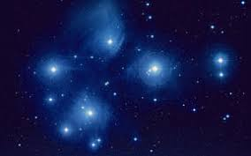

Find someone and greet eachother in te reo Māori

Share where you are from and your name

*Nō _______ ahau*

*Ko _______ tōku ingoa*

What else can you say in te reo during greetings and introductions?

Find someone and together consider our best practice as teachers of tamariki Māori



Talk with someone about how you are feeling about our

Aotearoa New Zealand’s Histories curriculum

Find someone who can tell you briefly of a local story of significance

