    

Find someone who shares with you some aspect of

*Tikanga Māori*

(Māori cultural protocol)



Find someone who knows the names of our local

***Iwi***

**who are**

***Mana Whenua***

of our local

***Te Āwhina Marae***

Find someone who can accurately pronounce these local place names:

Motueka

Moutere

Riuwaka

Kaiteretere

Find someone who is able to define briefly the concept of

Equity

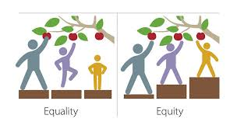

Find someone who shares something with you about

Te Tiriti o Waitangi

Find someone who shows manaakitanga (hospitable and kind, cares for others, shares with others, all their words and actions esteem other people, honours the MANA in other people)